Exercise 4: Arrange-Act-Assert (AAA) Pattern, Test Fixtures, Setup and Teardown Methods in JUnit

Code:-

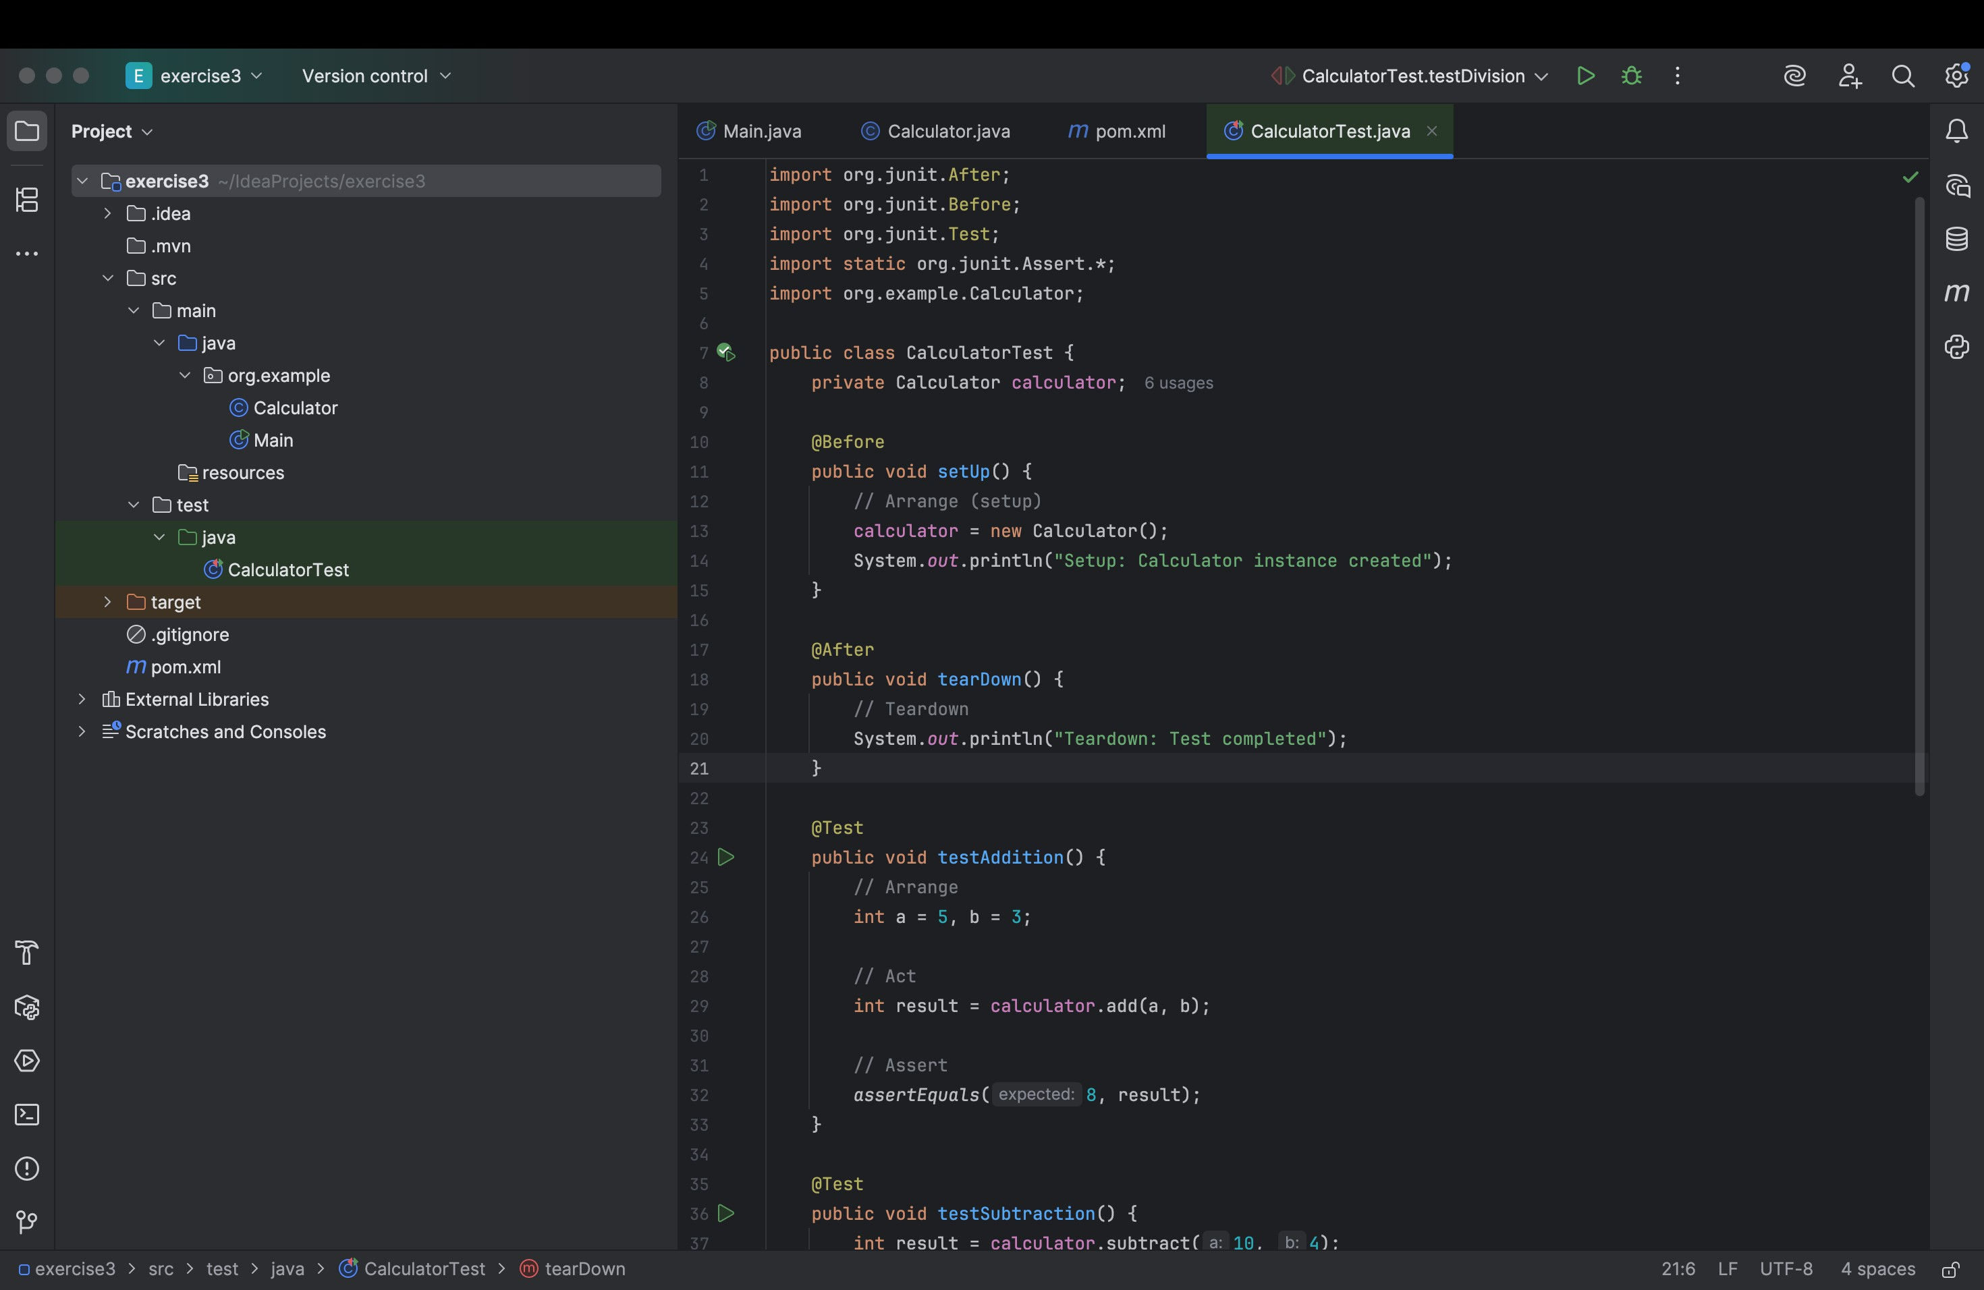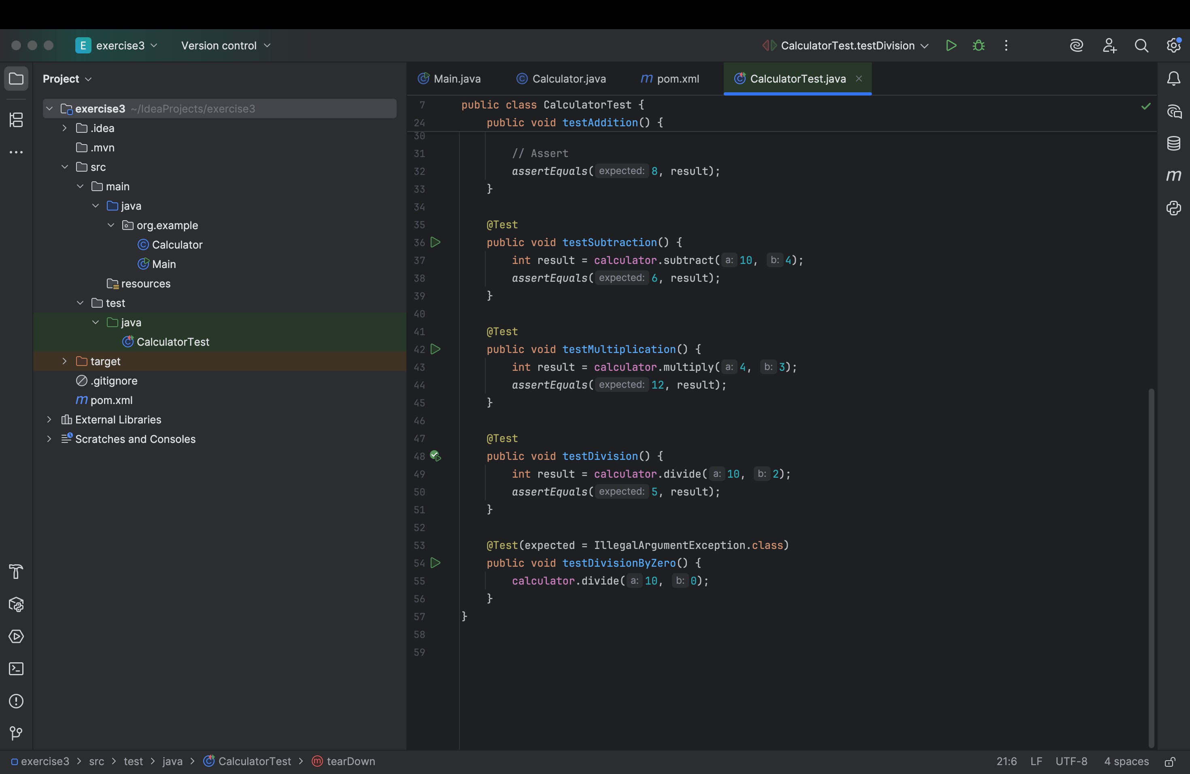

Output:-

